Commercially available devices:

Finger clips sensor manufactured by Kyto Electronics. Finger pulse sensor HRM-2511B.

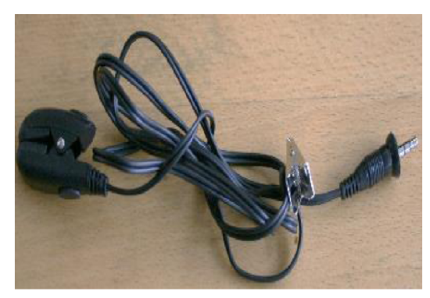

Sana Health has made a maskand headphones to wear overhead. it uses audio visual stimulation to increase balance between the left and right side of the brain leading to greater relaxation. Prolonged usage of this device will track patterns and will help to accelerate physical recovery and improve mental health and wellbeing. The device uses visual stimulations at low levels of light through closed eyes and heart rate variability measurement. coordinated pulses of light and sound guides the user into a deep state of relaxation, promoting increased recovery from fatigue and this data is connected to mobile app.

OneCare has made a wearable watch that uses this technology to remote watch patients and alert a guardian if anything goes wrong. It tracks their steps, heartrate and sleep monitor, location information, fall detection and SOS alert and send that data over the network to the guardian of the person via mobile app. Its connected to AT&T cellular network. It also provides data analytics so that doctors can track the trends. Companies such as Samsung and Apple also use this kind of tech in Samsung and Apple watch.

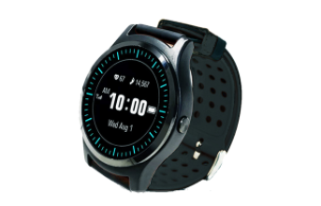

Kenzen Wearable patch system: This system is a wearable patch system to improve worker health and safety. The Kenzen patch continuously measures vital and factors associated with heat stress and tracks health of workers Working in extreme conditions such as coal mines and other construction sites.

Phlex: made a device using heart rate data to improve swimmer’s performance. Its main objective is for all swimmers to get the most out of their training.

Bodytrak: developed a solution for precise physiological monitoring using an earpiece providing automated real time data, audio, and predictive cloud-based analytics. The earpiece has sensor integration, audio alerts and onboard data processing and it is connected to a powerful system processing and communication.

Pulse Oximeter Fingertip: There are many pulse oximeters in use these days. These devices were around but they were strongly recognized during the COVID-19 Pandemic as patients with COVID-19 had breathing problems and this device was used to measure their oxygen level in the blood using light absorption in oxygenated and deoxygenated blood. There are many of these devices available in the market or Amazon.

